Programming Assignment – Pointer Manipulations
The function of this program is to manipulate an array using pointers. The functions listed below perform the transformations on an array, but entirely with pointers (you cannot use array notation within your functions except the int *initialize(int* size) function).
You have been provided with a program to do the following, but it has errors. You are required to fix the program so that it works as required.
The transformations are described in detail below, with the function prototypes given.
- The main() function first calls the initialize function, which is described below. It then enters a while loop presenting a menu of options as illustrated below.
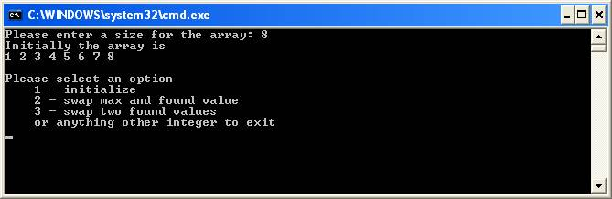
The program will continue to prompt the user for an action until the user chooses to exit.
- int* initialize(int* size) - Dynamically allocate and initialize an array. The parameter to the function is a reference variable which will store the size of the array. The function returns a pointer to the allocated array.
First, this function prompts the user to enter an array size. It then uses the array size to dynamically allocate an array and initialize the array to contain the values from 1 to the array size.
- int *maxValue(int *a, int size) - The first parameter to the function is a pointer to the array. The second parameter is the size of the array. The function returns a pointer to the maximum value in the array.
- int *find(int *a, int size) - The first parameter to the function is a pointer to the array. The second parameter is the size of the array. The function should prompt the user to enter an integer value. After the user enters a value, it tries to find the value in the array. If the value is not in the array, the user will continue to be prompted for another value to be found, until a value in the array is entered. The function returns a pointer to the found value in the array.
- void swap(int *a, int *b) - Swap the values pointed to by the parameters.
- void swapMaxAndFoundValue(int* a, int size) - Swaps the maximum value with a found value (by calling the three functions listed above).
An example is shown below.
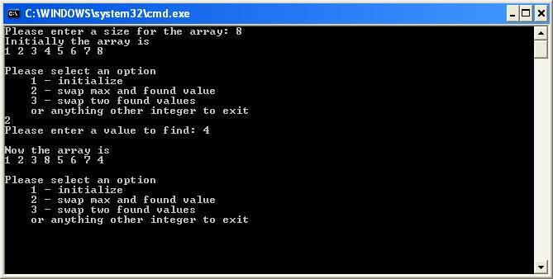
- void swapTwoFoundValues(int* a, int size) - Swaps two found value (by calling the functions listed above).
An example is shown below.
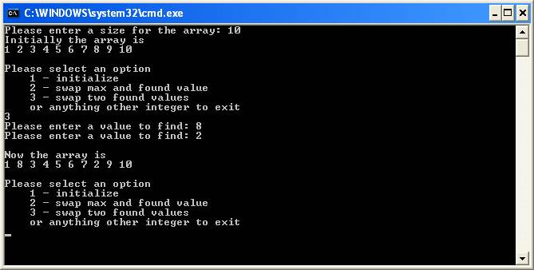

Input/Output
All input will use standard input (scanf). All output will use standard output (printf).

Cautions:
Some constraints on the assignment are listed below.
- Use the provided program that is giving here.
- Use the initialize function to initialize and allocate the array.
- Each transformation must be implemented in a function with the prototype as given above.
- Make sure that your functions stay within the array (does not go "out-of-bounds").
- Your job is to fix the provided program so that it works perfectly.
- Option 3 is currently empty. Once the errors are fixed, please complete option 3 so that it does what it is supposed to do.
Students should hand in a printout of the source code (make sure it is documented properly according to the UHCL guidelines). Please make sure that all this is in an envelope or folder. Students should also upload a soft copy of your program as before too.

